Conférence de presse BCE du 30 octobre 2025
Extraits des Q&A : questions sur l’euro numérique
PRESS CONFERENCE
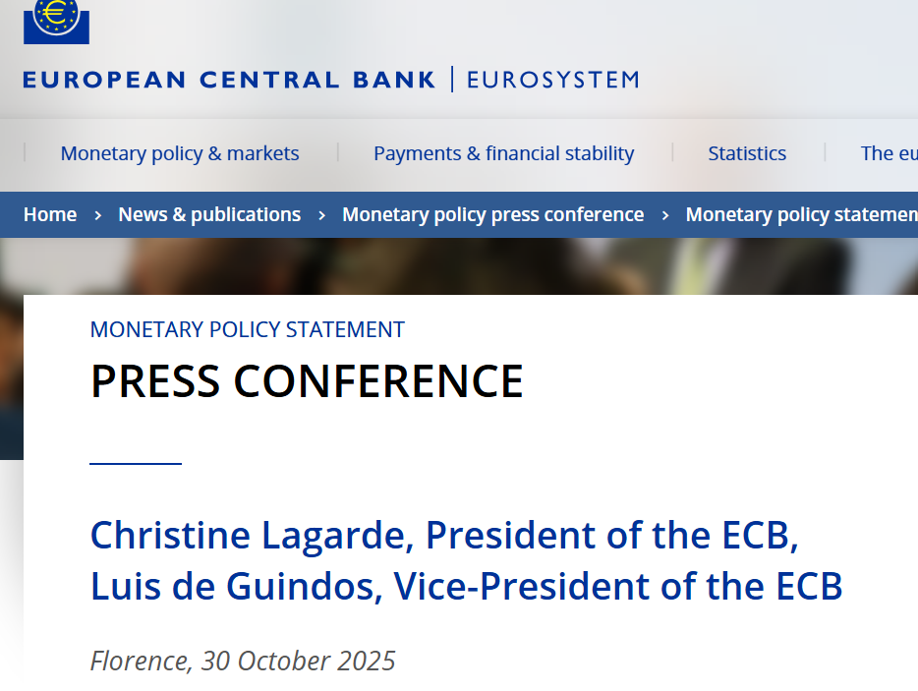
(…)
I have two questions on the digital euro. The first to President Lagarde. One of the objections of the criticism towards the project, which by the way was raised also by the rapporteur of the regulation in the European Parliament, is that the digital euro is a solution in search of a problem. And its objective might be better realized through a market-led solution and maybe helped by a smarter regulation. How do you respond to that criticism?
And the second one to Governor Panetta: banks around Europe, including Italian banks, have warned about the costs of adopting the digital euro, even suggesting that their costs could be higher than ECB estimates, as is sometimes the case with public infrastructures. Is the Eurosystem considering an option to lower those costs, and are you afraid banks might pass down those costs to the consumers?

President Lagarde: Thank you very much for your question. For me, as president of the ECB, I regard money as a public good. Money is a public good, full stop. And that public good, for many, many decades, has been built around central bank money, which is the anchor on which commercial money, which is created by banks, prospers and develops. But the anchor is critically important in order to make sure that money remains a public good.
So, in our mind, and certainly in my mind, central bank money has to remain an active part of the system that people can actually trust. If you think of digital euro, it's the digital form of a banknote. People want, need, to have their banknotes. Maybe in 10 years' time there will be fewer of those banknotes in circulation, but they will still need to have the certainty that a euro is a euro is a euro, just like a rose is a rose is a rose. And for me it is our mission to make sure that money remains that public good that is available to our compatriots. And we are working for the Europeans in that respect.
You know, when I hear that it's a project in search of a cause, I think of money as a public good, the sovereignty of the European authorities at large over their currency, and the way in which money stands: this is not a project in search of a cause. It embodies the capacity of Europe to defend itself and to transact with a currency that is its own.
There are many other reasons why the digital euro is perfectly legitimate, valid, and will be cheaper, user-friendly, good for transactions throughout Europe and not just in various countries on a national basis. But the key points for me is: money is a public good; central banks are the custodian of that public good; and central money issued by central banks has to have its digital form, because we're moving into a different era where not everybody will want necessarily to have banknotes.
Governor Panetta: Well, you did not ask me but, before I answer your question, I want to say that I strongly agree with what the President just said. We need public money for the stability of the financial system. So, the President is, as always, absolutely right.
On the costs, I think it would be unwise to discuss costs before discussing the benefits. Currently, euro area banks only represent one third of total activity on digital payments in the euro area. Two thirds of digital payments in the euro area are intermediated by non-European companies, both for digital payments at the point of sale and digital payments online.
Now the reason why this is so is that European banks did not agree until now on ways to provide their services to the entire euro area. They don't have what is called in technical terms a rail, the infrastructure to provide, to offer their digital payment services to all European citizens.
One of the main benefits for banks – there are many benefits for consumers, there are benefits for the stability of the financial system – but one of the main benefits for the banks in the euro area is that once the digital euro infrastructure will be built, they will be able, by using this so-called open standard infrastructure, to use that rail and compete at a European level, thus generating additional business, additional revenues, and there will be many implications in terms of sovereignty for the euro area, in terms of control of the information that travels with your payments.
This is the first part of my comment. Second: the costs.
Now, there are estimates on the cost of adoption, because the construction of the digital euro will be paid by the Eurosystem. The costs, I don't know if the estimates which are available are correct, discuss numbers of about 6 billion euros for four years. Now if you think that we have 2,000 banks in the euro area, for four years, this means that the cost of adoption is a few hundred thousand euros per year per bank. Now even forgetting the benefits I just mentioned, the costs of adoption are not so high. They represent overall about 3% of total yearly IT costs for the banks.
So, then who will pay those costs? Well, it depends on the competition on the payment market. If the digital euro would be introduced, competition would be higher, and the banks would not be able to transfer those costs to consumers. So it would be limited, there would be additional revenues, and then the cost would be allocated depending on competition, and competition will improve.
President Lagarde: Let me say that I agree with my colleague and friend Mr Panetta who by the way, for those of you who don't know, has been one of the architects of this project, and I pay tribute to him.

(…)
My question goes back to money and payments, basically. We in Europe are in an environment in which public money, as you said, and public cash, actually digital cash, is going to be a key feature of the future of payments. In the United States, at the same time, we are witnessing a strong push towards stablecoins, towards crypto, and actually what is a ban on central bank digital money. So, it is paramount, as I understand it, we at some point reach an agreement that there is some kind of harmonisation at the global level.
Now, since you're back from the IMF meetings in Washington, my question is, at what stage is this process? At what stage are negotiations towards some kind of coordination with the US administration?
President Lagarde: First of all, I would like to insist on the fact that we at the ECB, in the Eurosystem, are very attentive to innovation, and we are very supportive of innovation. The digital euro, the different options that we're exploring, the way in which we reach out to suppliers, merchants, banks, which stand to benefit from this system, is a clear indication that we want innovation into money and into this public good for which we are responsible.
So, for those who would like to argue that we are trying to stifle innovation, terribly sorry, but no. You're knocking at the wrong door. Innovation is definitely part of us and part of the DNA of central bankers in Europe.
Second, we are also attentive to the regulatory framework in which private forms of money, certain financial instruments that I would not call currencies, and I'm here referring to cryptos, equivalent of currencies as they present themselves, but which are private form of money such as stablecoins, are launched, are reserved against, are made secure. And that was under the MiCAR, which was the European regulation that was issued in order to establish the protection of consumers, enough financial stability, and rules by which some of those issuers were supervised.
I observed, by the way, that in spite of the executive decision that was made back in January, the GENIUS Act, which was issued by Congress in the United States is also attempting to put together a framework which has a lot of overlap with MiCAR. There are some discrepancies and there are areas for which we have to be attentive not to create financial stability risk or arbitrage risks that would be detrimental to Europe. This is our job and we will continue to do that job and to have a dialogue with the Commission which is in charge of establishing the rules of the game, if you will.
But as I said earlier, what we are doing, putting money as a public good on the map and making sure that the anchor is alive and digital as well as cash, is our duty. But it does not stop private issuers from doing what they think is their business. They're into market share. They're into penetration of certain spheres of either payment or transactions. But our job is to secure the anchor. Our job is to secure the settlement functions. And we are going to continue doing that, notwithstanding initiatives that some of those issuers will take. And it certainly does not preclude European-based issuance that would be in compliance with the regulatory framework that we have.
So, it's a vibrant domain, but one where we have to make sure that we do not expose our compatriots or our economy to financial instability risk that would certainly be a recurrence of what we observed back in 1890 in the United States, for instance.

